
AAT REPORT ON
Design and Verification of Combinational and Sequential Digital Modules using Verilog HDL
COURSE: ADVANCE DIGITAL LOGIC DESIGN (23EC5PE1AD)

Submitted by
Praveen R Halagi 1BM25EC432

Submitted to
Prof. Ajaykumar Devarapalli
Assistant Professor

DEPARTMENT OF ELECTRONICS AND COMMUNICATION ENGINEERING
BMS College of Engineering Bull Temple Road, Basavanagudi, Bengaluru-560019

Academic Year 2026 – 2027

VERILOG CODES

ARITHMETIC LOGIC UNIT (ALU)
An ALU is a combinational circuit that performs arithmetic and logical operations on binary data. It performs operations such as addition, subtraction, AND, OR, and XOR. The operation is selected using control or select lines. The output depends on the input data and the selected operation.

DESIGN

ARITHMETIC LOGI
Y[3:0]
SEL[3:0]
A[3:0]

B[3:0]

VERILOG CODE
module alu ( input [3:0] A, B, input [2:0] sel, output
reg [3:0] Y

);
always @(*) begin case (sel)
3'b000: Y = A + B;
3'b001: Y = A - B;
3'b010: Y = A & B;
3'b011: Y = A | B;
3'b100: Y = A ^ B;
default: Y = 4'b0000; endcase end endmodule

Test bench: module tb alu; reg [3:0] A, B; reg [2:0] sel; wire [3:0] Y; alu uut (.A(A), .B(B), .sel(sel), .Y(Y)); initial begin A=4'd5; B=4'd3;
sel=3'b000; #10; sel=3'b001; #10;
sel=3'b010; #10; sel=3'b011; #10;
sel=3'b100; #10;

$finish; end endmodule

COMPARATOR
A comparator is a combinational circuit used to compare two binary numbers. It determines whether the first number is greater than, less than, or equal to the second number. It produces three outputs: greater than, less than, and equal. The outputs depend on the values of the input numbers.

DESIGN
A[3:0]
A=B

COMPARATOR
A>B
A<B

B[3:0]

VERILOG CODE
module comparator ( input [3:0] A, B, output gt, lt, eq
);
assign gt = (A > B); assign lt = (A < B);

assign eq = (A == B); endmodule

TEST BENCH:
module tb_comparator; reg [3:0] A, B; wire gt, lt, eq; comparator uut (.A(A), .B(B), .gt(gt), .lt(lt), .eq(eq)); initial begin A=5; B=3; #10;
A=2; B=7; #10;
A=4; B=4; #10;
$finish; end endmodule

4-BIT PARITY GENERATOR AND CHECKER
A parity generator generates a parity bit to detect errors in binary data. It uses XOR gates to generate even or odd parity for a 4-bit input. A parity checker checks the received data along with its parity bit. If the parity is incorrect, an error is detected.

DESIGN

4 BIT PARITY GENERATOR AND
CHECKER
DATA[3:0]
PARITY_IN
PARITY OUT
ERROR

VERILOG CODE
module parity ( input [3:0] data,

input parity_in, output parity_out, output error
);
assign parity_out = ^data; assign error = ^{data, parity_in}; endmodule

TEST BENCH:
module tb_parity; reg [3:0] data; reg parity_in; wire parity_out, error;
parity uut (.data(data), .parity_in(parity_in), .parity_out(parity_out), .error(error)); initial begin
data=4'b1010; parity_in=1'b0; #10;
parity_in=1'b1; #10; data=4'b1110; parity_in=1'b0; #10; $finish; end endmodule

4-BIT BARALLEL SHIFTER
A barrel shifter is a combinational circuit used to shift binary data by a specified number of positions. It can perform left or right shifts depending on the control input. The shift amount is selected using control lines. It performs shifting in a single operation without requiring multiple clock cycles.

DESIGN
 |  | 4-BIT BARALLEL SHIFTER
A[3:0] |  | 4-BIT BARALLEL SHIFTER
SHAMT[1:0](SHIFT AMT) |  | 4-BIT BARALLEL SHIFTER
DIR(DIRECTION) |  | 4-BIT BARALLEL SHIFTER

Y[3:0] SHIFTED OUTPUT

VERILOG CODE
module barrel_shifter ( input [3:0] A, input [1:0] shamt, input dir, output reg [3:0] Y
);
always @(*) begin
if (dir == 1'b0) Y
= A << shamt; else

Y = A >> shamt;
end
endmodule

TEST BENCH:
module tb_barrel; reg [3:0] A; reg [1:0] shamt; reg dir; wire [3:0] Y;
barrel_shifter uut (.A(A), .shamt(shamt), .dir(dir), .Y(Y)); initial begin

A=4'b1010; shamt=1; dir=0; #10; shamt=2; dir=1; #10; shamt=0; dir=0; #10;
$finish; end endmodule

TIMER MODULE
A timer module counts clock pulses to measure a specific time interval. It uses a counter that increments with each active clock edge. When the counter reaches the specified value, the timer generates an output signal. A reset signal initializes the counter to zero.

DESIGN
CLK

TIMER COUNTER
RESET
DONE

VERILOG CODE
module timer ( input clk, reset,
output reg done

);
reg [3:0] count;
always @(posedge clk or posedge reset) begin if (reset) begin count <= 0; done <= 0; end else if (count == 9) begin
count <= 0; done <= 1; end else

begin count <= count + 1; done <= 0; end end endmodule

TEST BENCH:
module tb_timer; reg clk, reset; wire done;
timer uut (.clk(clk), .reset(reset), .done(done)); always #5 clk = ~clk;
initial begin clk=0; reset=1; #10 reset=0;
#120 $finish; end endmodule

RING COUNTER
A ring counter is a sequential circuit made using a shift register with its output connected back to its input. It circulates a single logic 1 through the register during each clock pulse. A reset initializes the counter to a known state. For a 4-bit ring counter, the sequence normally contains four distinct states.

DESIGN
RESET
Q[3:0]

RING COUNTER
CLK

VERILOG CODE
module ring_counter ( input clk, reset, output reg [3:0] q
);
always @(posedge clk or posedge reset) begin if (reset) q <= 4'b0001; else
q <= {q[2:0], q[3]};
end endmodule

TEST BENCH:
module tb_ring; reg clk, reset; wire [3:0] q;
ring_counter uut (.clk(clk), .reset(reset), .q(q)); always #5 clk = ~clk; initial begin clk=0; reset=1; #10 reset=0; #80 $finish; end endmodule

JOHNSON COUNTER
A Johnson counter is a sequential circuit in which the inverted output of the last flip-flop is connected to the input of the first flip-flop. register shifts its data on every active clock edge. An n-bit Johnson counter can generate up to 2n distinct states. It is used in sequence generation and digital control circuits.

DESIGN
CLK

JOHNSON COUNTER
Q[3:0]

RESET

VERILOG CODE
module johnson_counter ( input clk, reset,
output reg [3:0] q

);
always @(posedge clk or posedge reset) begin if (reset) q <=
4'b0000; else q <=
{q[2:0], ~q[3]}; end endmodule

TEST BENCH
module tb_johnson; reg clk, reset; wire [3:0] q;
johnson_counter uut (.clk(clk), .reset(reset), .q(q)); always #5 clk = ~clk; initial begin clk=0; reset=1; #10 reset=0; #100 $finish; end endmodule

SYNCHRONOUS COUNTER
In a synchronous counter, all flip-flops receive the same clock signal. All flip-flops change their states together at the active clock edge. It provides faster operation because the flip-flops are triggered simultaneously.

DESIGN
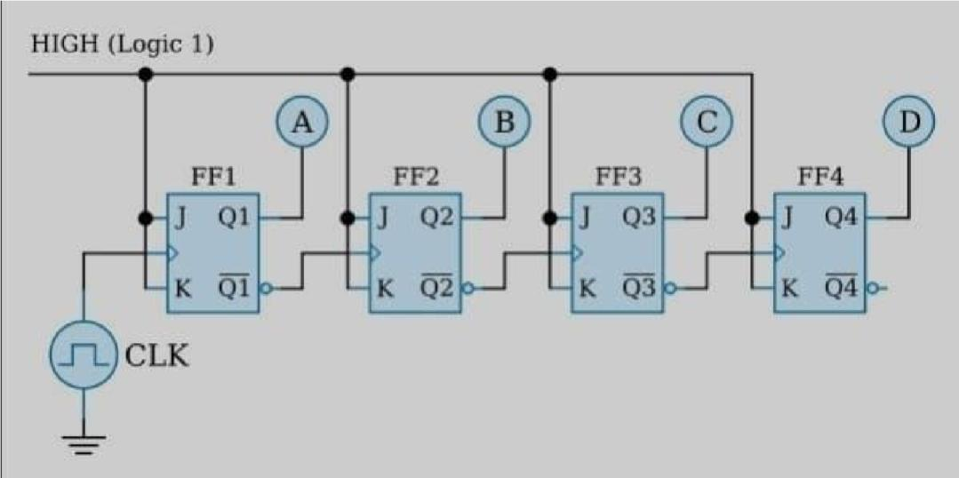

VERILOG CODE
module sync_counter ( input clk, reset,
output reg [3:0] q

);
always @(posedge clk or posedge reset) begin if (reset) q <= 4'b0000; else
q <= q + 1'b1; end endmodule

TEST BENCH:

module tb_sync; reg clk, reset; wire [3:0] q;
sync_counter uut (.clk(clk), .reset(reset), .q(q)); always #5 clk = ~clk; initial begin clk=0; reset=1; #10 reset=0; #180 $finish; end endmodule

ASYNCHRONOUS COUNTER
In an asynchronous counter, only the first flip-flop receives the external clock directly. The output of one flip-flop acts as the clock for the next flip-flop. The changes propagate through the counter, causing cumulative propagation delay.

DESIGN

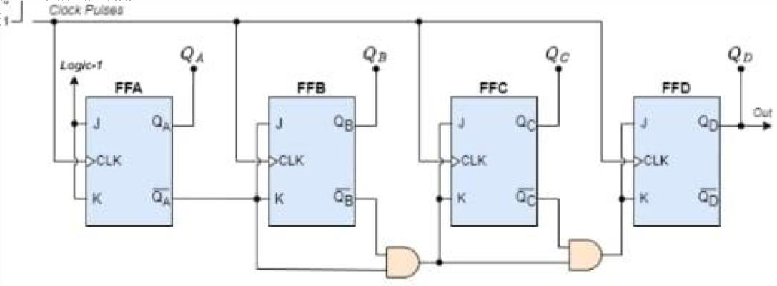

VERILOG CODE
module async_counter ( input clk, reset,
output reg [3:0] q

);

always @(posedge clk or posedge reset) begin if (reset) q[0] <= 0; else q[0] <= ~q[0]; end
always @(negedge q[0] or posedge reset) begin if (reset) q[1] <= 0; else q[1] <= ~q[1]; end
always @(negedge q[1] or posedge reset) begin if (reset) q[2] <= 0; else q[2] <= ~q[2]; end
always @(negedge q[2] or posedge reset) begin if (reset) q[3] <= 0; else q[3] <= ~q[3]; end endmodule

TEST BENCH:
module tb_async; reg clk, reset; wire [3:0] q;
async_counter uut (.clk(clk),
.reset(reset),
.q(q)); always #5 clk = ~clk; initial begin clk=0; reset=1; #10
reset=0; #180
$finish; end endmodule

SHIFT REGISTER
A shift register is a sequential circuit used to store and shift binary data. It consists of a group of flip-flops connected in series. At every active clock edge, data shifts from one flip-flop to the next. It is used for temporary data storage and serial-to-parallel or parallel-to-serial conversion.

DESIGN
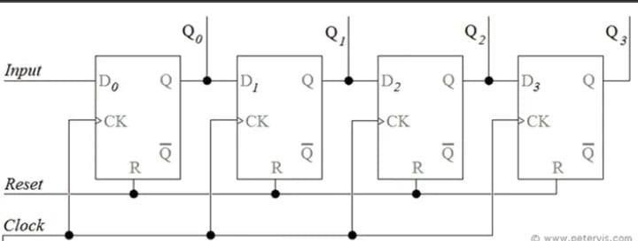

VERILOG CODE
module shift_register ( input clk, reset, serial_in, output reg [3:0] q
);
always @(posedge clk or posedge reset) begin if (reset) q <= 4'b0000; else
q <= {q[2:0], serial_in}; end endmodule

TEST BENCH:
module tb_shift; reg clk, reset, serial_in; wire [3:0] q;

shift_register uut ( .clk(clk), .reset(reset), .serial_in(serial_in), .q(q)); always #5 clk = ~clk; initial begin
clk=0; reset=1; serial_in=0; #10 reset=0;
serial_in=1; #10;
serial_in=0; #10;
serial_in=1; #10;
serial_in=1; #10;
#30 $finish; end endmodule

DIVIDE BY N COUNTER
A divide-by-N counter divides the input clock frequency by a specified number N. It counts clock pulses from zero to N−1 and then resets to zero. A suitable output signal is generated based on the counter state. It is used in clock division and frequency control circuits.

DESIGN
RESET
CLK

DIVIDE BY N COUNTER
DIVIDE BY N COUNTER |  | CLK_OUT

VERILOG CODE
module divide_by_n ( input clk, reset,
output reg clk_out

);

reg [3:0] count;
always @(posedge clk or posedge reset) begin if (reset) begin count <= 0; clk_out
<= 0; end else if (count == 9) begin

count <= 0; | clk_out <= ~clk_out; | end
else begin | count <= count + 1'b1; | end
end
endmodule

TEST BENCH:
module tb_divide; reg clk, reset; wire clk_out;
divide_by_n uut (.clk(clk), .reset(reset), .clk_out(clk_out)); always #5 clk = ~clk; initial begin clk=0; reset=1; #10 reset=0; #250 $finish; end endmodule

MELAY FSM
A Mealy finite state machine produces its output based on the present state and current input. Its output can change immediately when the input changes. It generally requires fewer states than an equivalent Moore machine. It is used in sequence detectors and digital control systems.
This example detects the input sequence 101. The output becomes 1 when the final 1 completes the sequence, and the output depends on both the current state and input.

DESIGN
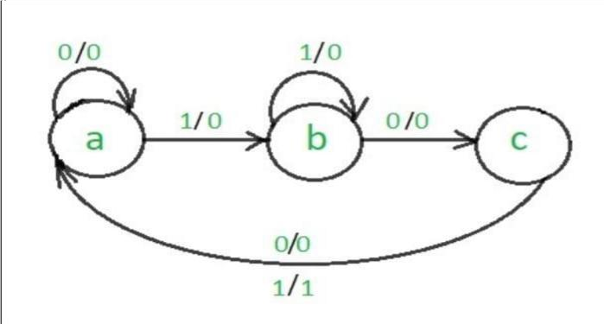

VERILOG CODE
module mealy_fsm ( input clk, reset, din,
output reg detected

); reg [1:0] state; local param S0=0, S1=1, S2=2; always @(posedge clk or posedge reset) begin if (reset) begin state <= S0; detected <= 0; end else begin
detected <= 0; case (state) S0: if (din) state <= S1; else state <= S0; S1: if (din) state <= S1; else state <=
S2; S2: if (din) begin state <= S1; detected <= 1;
end else state <= S0; default: state
<= S0; endcase end end
endmodule

TEST BENCH
module tb_mealy; reg clk, reset, din; wire detected;

mealy_fsm uut (.clk(clk), .reset(reset), .din(din), .detected(detected)); always #5 clk = ~clk; initial begin clk=0; reset=1; din=0;
#10 reset=0;
din=1; #10; din=0;
#10; din=1; #10;
din=0; #10; din=1;
#10; din=0; #10;

$finish;

end endmodule

MOORE FSM
A Moore finite state machine produces its output based only on the present state. Its output changes when the machine transitions to another state. The output is generally more stable because it does not depend directly on the current input. It is used in controllers and sequence detection circuits.
This example also detects the sequence 101. The output becomes 1 in a dedicated detection state, so it depends only on the current state
.

DESIGN
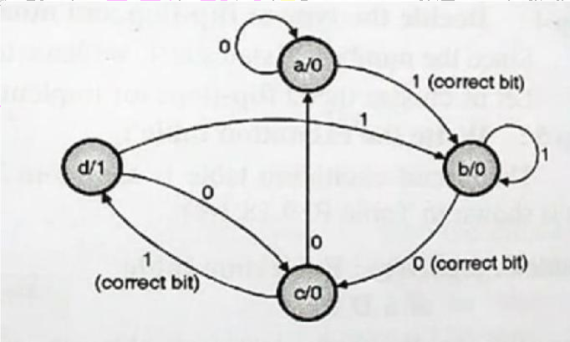

end

VERILOG CODE
module moore_fsm ( input clk, reset, din,
output detected

); reg [1:0] state;
localparam S0=0, S1=1, S2=2, S3=3; assign detected = (state == S3); always @(posedge clk or posedge reset) begin if (reset)
state <= S0; else begin case (state)

S0: if (din) state <= S1; else state <= S0; S1: if (din) state <= S1;
else state <= S2; S2: if (din) state <= S3;
else state <= S0;
S3: if (din) state <= S1; else state <= S2;
default: state <= S0; endcase

end endmodule

TEST BENCH:
module tb_moore;

reg clk, reset, din; wire detected;
moore_fsm uut (.clk(clk), .reset(reset), .din(din), .detected(detected)); always #5 clk = ~clk; initial begin clk=0; reset=1; din=0; #10 reset=0; din=1; #10; din=0; #10; din=1; #10; din=0; #10;
din=1; #10;

#20 $finish; end endmodule

RANDOM SEQUENCE GENERATOR
A random sequence generator produces a sequence of binary values that appears random. It can be implemented using a Linear Feedback Shift Register (LFSR). The circuit uses shift registers and XOR feedback to generate different bit patterns. It is commonly used in testing digital circuits and generating pseudorandom sequences.

DESIGN
RESET
CLK
RANDOM SEQUENCE GENERATOR
RANDOM SEQUENCE GENERATOR |  | Q[3:0]

VERILOG CODE
module lfsr ( input clk, reset, output reg [3:0] q
);
always @(posedge clk or posedge reset) begin if (reset) q <= 4'b0001; else
q <= {q[2:0], q[3] ^ q[2]};
end

endmodule

TEST BENCH:
module tb_lfsr;
reg clk, reset; wire [3:0] q; lfsr uut (.clk(clk), .reset(reset), .q(q)); always #5 clk = ~clk; initial begin clk=0; reset=1; #10 reset=0; #200
$finish; end endmodul

